**APACH Forum Fosters Regional Collaboration and Innovation; Nepal a part of it**

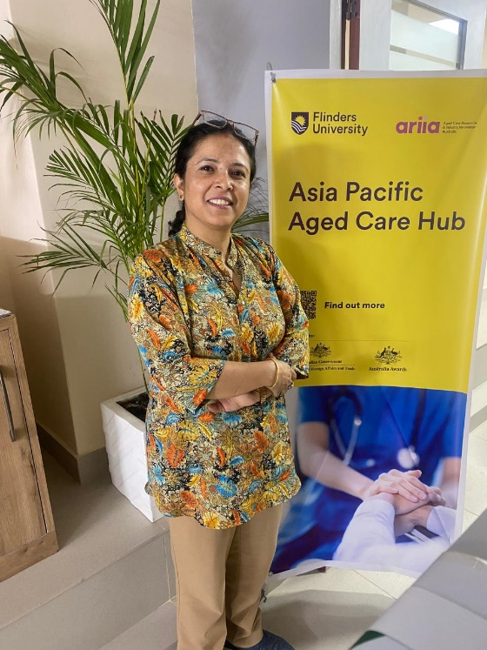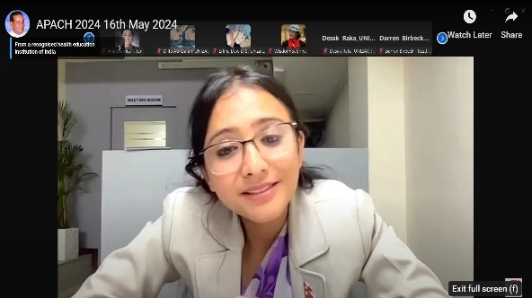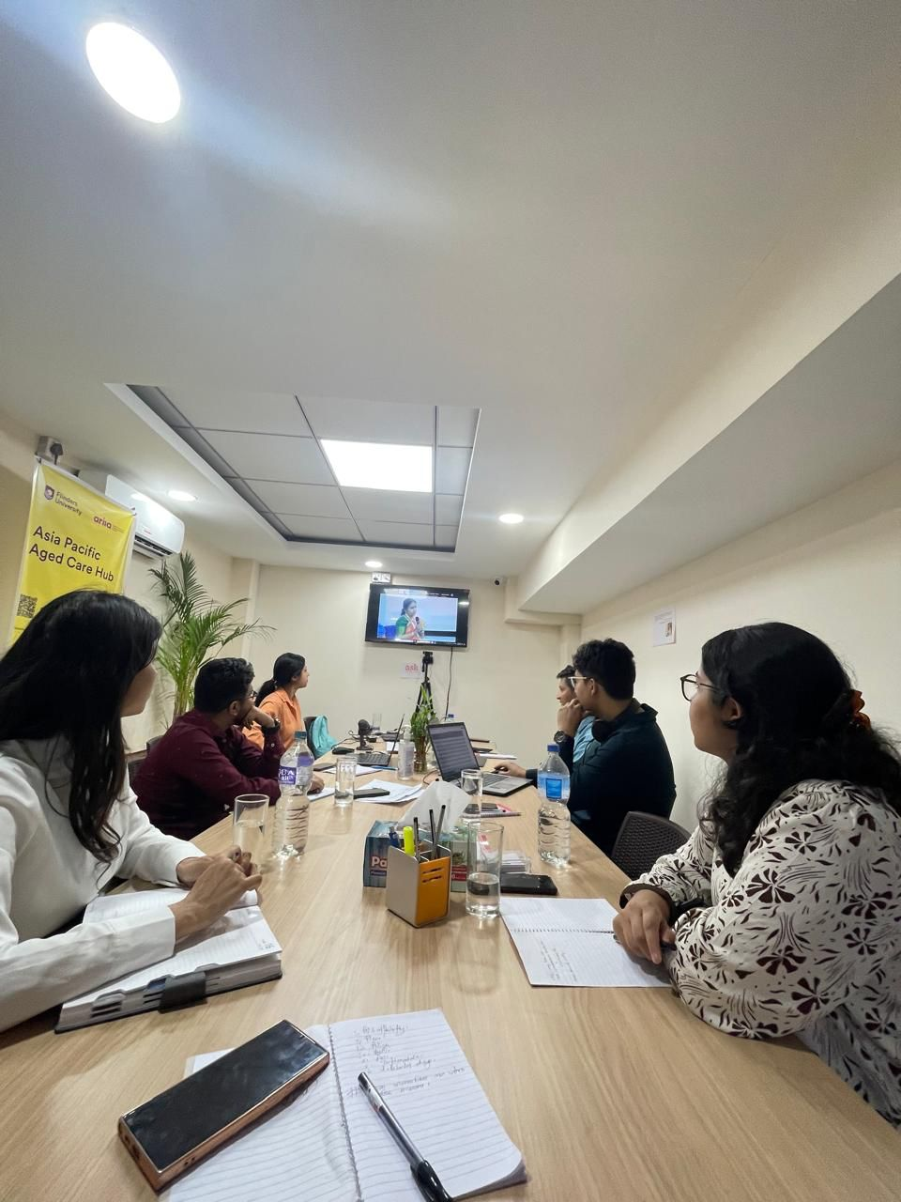

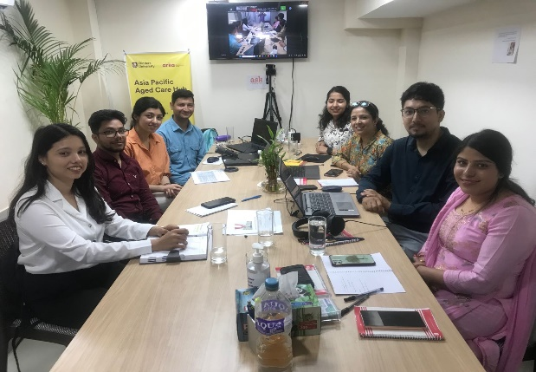

The Asia Pacific Aged Care Hub International Policy Forum (APACH), held at Ramaiah Medical College in Bangalore on the 16th and 17th May 2024, has marked a significant milestone in fostering collaboration and innovation in the aged care sector across the Asia Pacific region. Organized in partnership with Flinders University, Adelaide, and Aged Care Research and Industry Innovation Australia (ARIIA), the forum received support from the Australian Government Department of Foreign Affairs and Trade through the Australia Awards Fellowships Program.

The forum also marked the completion of a 12-month fellowship program by distinguished Fellows from various countries, including Dr. Prabhat Adhikari and Assistant Professor Kabin Maleku from Nepal, as well as Fellows from the Philippines, Indonesia, Bangladesh, Malaysia, and India. This diverse group of Fellows underscored the forum's commitment to regional collaboration in addressing aged care challenges.

ASK Foundation, a not-for-profit organization, conducted a satellite hub for the forum at CAMS Clinic, New Baneswor. Dr. Toshima Karki, a member of Nepal's parliament, delivered a keynote speech addressing the policy challenges and current conditions of aged care in Nepal. Her insights underscored the urgent need for policy reforms and increased investment in aged care infrastructure. Furthermore, Dr. Bindu Pandey KC, head of the Emergency Department at Norvic International Hospital and Medical College, served as a panelist, highlighting the potential of advanced technology to address global challenges with local solutions.

Additionally, three abstract papers from Nepal were presented at the forum. Anjana Thapa, Rubisha Adhikari, and Kushal Subedi each presented on critical topics: aged care policy, the quality of life of the elderly, and polypharmacy among elderly inpatients, respectively. These presentations provided valuable insights and underscored the importance of research in shaping effective aged care strategies.

This pioneering event brought together leading experts, policymakers, and industry innovators to address the pressing challenges and opportunities in aged care. Discussions centered on integrating advanced technologies and innovative practices to improve aged care services. Participants explored policies and strategies for enhancing the quality of life for the elderly throughout the region.

To watch the record of forum

16th May Video Link- <https://www.youtube.com/watch?v=59eWs_x0gEk&t=18460s>

17th May Video Link- <https://youtube.com/live/ySv96FbGwnI?feature=share>

APACH Forum Website- <https://www.apachintlforum.net/>

Written by

Anjana Thapa

[thapaanjana44@gmail.com](mailto:thapaanjana44@gmail.com)